FUNCTIONAL REQUIREMENTS

**Project Name :**

Opencart (E-commerce website)

URL: https://awesomeqa.com

**Prepared By :** Nitesh kumar

**Email**: [Niesh03kumar01@gmail.com](mailto:Niesh03kumar01@gmail.com)

**Github**: @Niteshkumar76

## Overview

OpenCart is free open source e-commerce platform for online merchants. OpenCart provides a professional and reliable foundation from which to build a successful online store. This foundation appeals to a wide variety of users; ranging from seasoned web developers looking for a user-friendly interface to use, to shop owners just launching their business online for the first time. OpenCart has an extensive amount of features that gives you a strong hold over the customization of your store. With OpenCart's tools, you can help your online shop live up to its fullest potential.

## Requirements

OpenCart requires certain technical requirements to be met for the store to operate properly. First, a web server must be created to make the OpenCart store publicly available on the web. Domain names and hosting services can easily be purchased for an affordable price.

When selecting a hosting service, you should check to see that these server requirements are provided and installed on their web servers:

These extensions must be enabled for OpenCart to install properly on the web server.

* PHP 5.4
* jQuery 2.1.1
* JavaScript
* Database (MySQL suggested)
* Web Server (Apache suggested)

## Opencart Frontend

This Document is intended to be used as an introduction to the OpenCart default store front. The store front reveals how the customer views and interacts with the store.

# **Navigating the shop**

The OpenCart default theme makes navigating a shop's products easily accessible to its customers.

## **Home page**

The home page is arguably the most important page in the shop, in terms of presentation. In most cases, this will be the first page that a customer interacts with (especially if they are directed to the store site from a search engine). The shop's homepage needs to be user-friendly, while at the same time highlighting the shop's products.

The first step in becoming familiar with the store front is understanding the anatomy of the OpenCart default homepage.

.

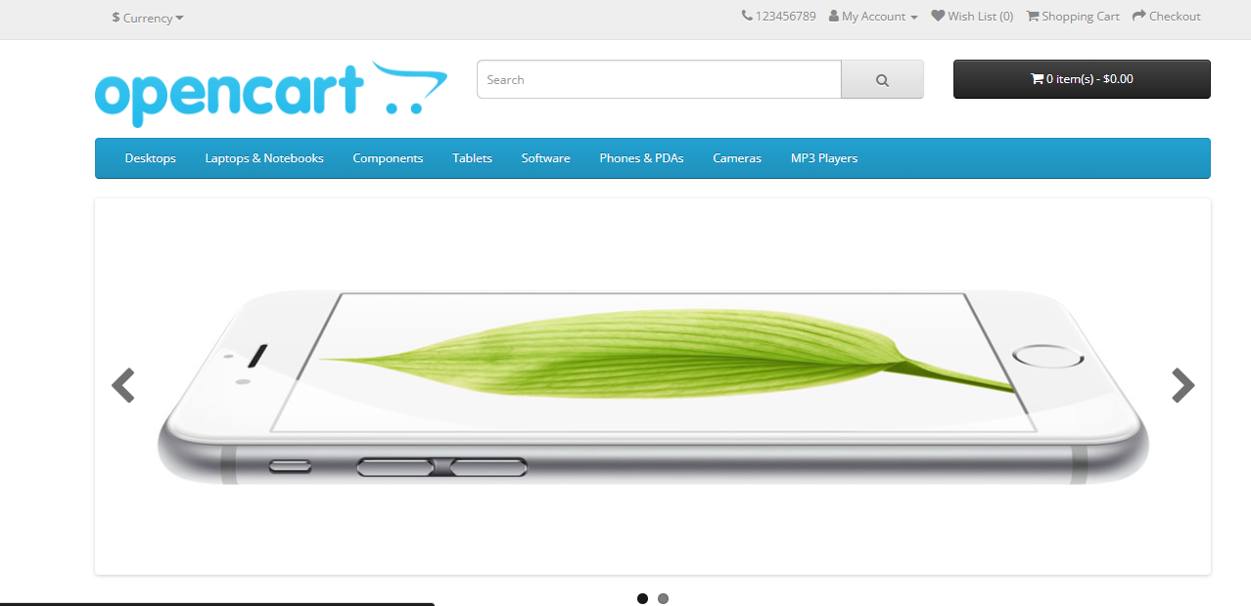

The header has the following navigation options:

1.Store logo: Clicking on this logo will direct the customer back to the home page of the store.

2.Currency block: The customer can select which currency the store's products will be in by clicking on any of the currency icons.

3.Shopping Cart: Displays the number of items purchased, and the total price of the order. Clicking on the button will containing all of products added to the cart and an option to "View Cart" or "Checkout".

4.Search box: The customers can type in the search box to search for a product within the store's product categories.

5.Links: Links the customer to the Home page, Wish List, My Account, Shopping Cart, and Checkout.

6.Telephone: Company telephone number.

7.My Account: Customer can register or login from here.

### Featured products

OpenCart gives you the option of featuring specific products of their choosing on the home page.

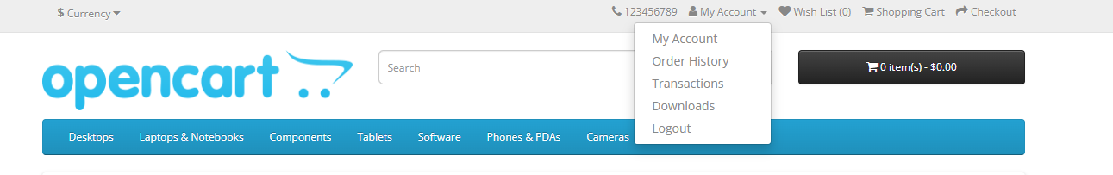

The product page can be divided into the following sections:

* **Product image:** The product image can be displayed under the title on the left-side, along with alternate views of the product underneath it in smaller box. Clicking on the main image will expand the image within the window for the customer to see it in greater detail.
* **Product details:** The product code, availability, and price are displayed just right to the product image.
* **Cart:** The customer can select a quantity and add the product to their cart, wish list, or compare.
* **Rating/Sharing:** Underneath the cart can rate the product and/or share the product on different social media websites.
* **Description tab:** An area underneath the main product information to provide a detailed description of the product.
* **Review tab:** An area for the customer to write a review on the product.

## 0 **Shopping Cart page**

Once a customer adds a product to the cart, they can access the shopping cart in the header under "Shopping Cart". 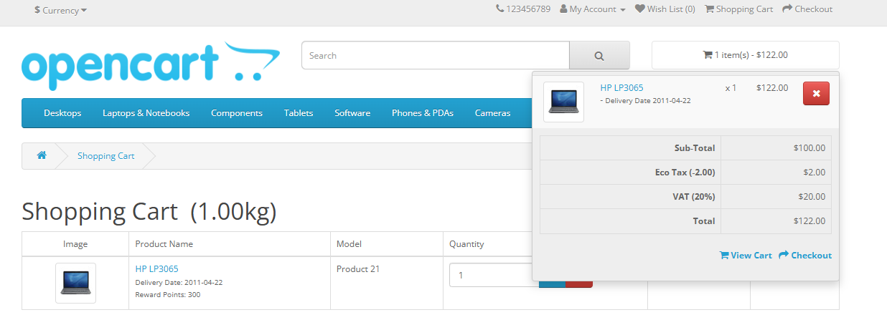

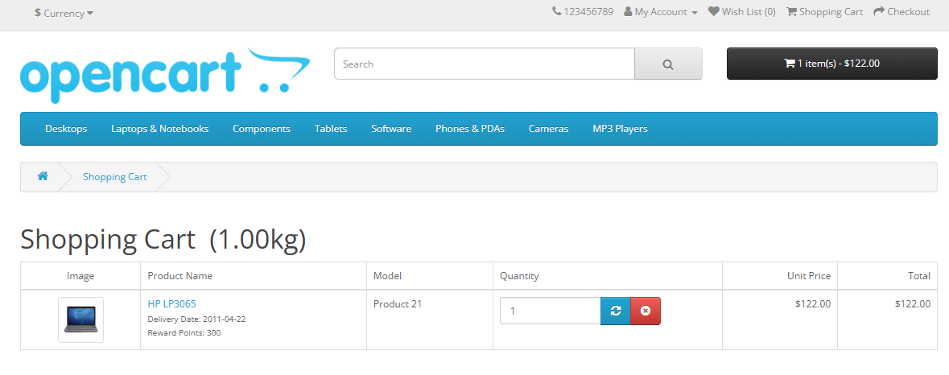



Footer

The footer is located at the bottom of every page, not just the Home Page. This block of miscellaneous links is useful in sorting relevant pages for the customer that may not logically sort anywhere else.

The organizational scheme of the footer can be divided into the following sections:

* **Information:** "About Us", "Delivery Information", "Privacy Policy", "Terms & Conditions"
* **Customer Service:** "Contact Us", "Returns", "Site Map"
* **Extras:** "Brands", "Gift Vouchers", "Affiliates", "Specials"
* **My Account:** "My Account", "Order History", "Wish List", "Newsletter"

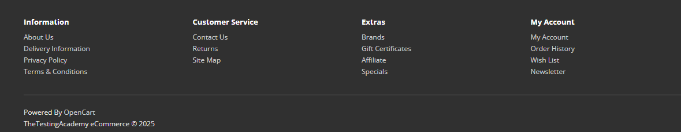

## **Checkout**

Once a product has been added to the cart, the customer can continue to the checkout to make their product purchase. The Checkout page can be accessed in the header section of every page (found under the search box). Customer checkout using OpenCart is a simple process that can be completed in 6 steps.

### 1. Step 1: Checkout options

The customer can log into or register their account (as explained above), or select guest checkout.

### 2. Step 2: Billing details

Personal details including "First Name", "Last Name", "E-mail", and "Telephone" are filled into a form. It also requires the customer's address details.

### 3. Step 3: Delivery details

In Billing Details, the user can check a box to indicate that the delivery details and billing details are the same. This will cause it to skip over this step to Delivery Method.

### 4. Step 4: Delivery method

A method of shipping is selected here. A comment box is added for the customer to add comments about their order.

### 5. Step 5: Payment method

The customer selects their method of payment here and may add comments in the comment box.

### 6. Step 6: Confirm order

In this last step, the customer will see an overview of their purchase; including the product description, quantity, and price (with tax & shipping).

